**Classroom Activity​: Write a function to generate the Fibonacci series up to a given number of terms. write code in js​**

**​**

**Code-**

const numberOfTerms = 10; // You can change this value to generate a different number of terms

let fibonacciSeries = [];

if (numberOfTerms <= 0) {

console.log("Please enter a positive number of terms.");

} else {

// Initial values

let a = 0, b = 1;

for (let i = 0; i < numberOfTerms; i++) {

fibonacciSeries.push(a);

let nextTerm = a + b;

a = b;

b = nextTerm;

}

console.log(fibonacciSeries);

}

**Output-**

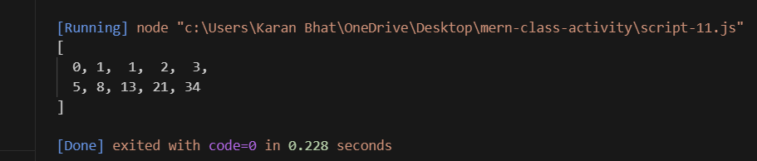

**Execution-Steps:**

* Create a JavaScript file with any name
* Write the code
* Run the code in the terminal using F5 or right click and go to inspect and you can get the output in the console as well.